ELECTRICITY BILL SYSTEM

KYATHISREE KARUMAJJI

RA2111026010464

CSE AI&ML(Y2 SECTION)

#include <stdio.h>

#include <conio.h>

int main()

{

int units;

float total_bill;

printf("#########################################################################################################################\n");

printf(" \t\t++++ELECTRTICITY DEPPARTMENT++++\n");

printf("*****************************************\ n");

printf("ELECTRICITY BOARD RATE CHART (Rates/Unit)\n");

printf("An electricity board charges the following rates to domestic users to discourage large consumption of energy:\n");

printf("0 Unit to 50 Units =Rs.2.5/Unit\n");

printf("51 Units to 100 Units =Rs.3/Unit\n");

printf("101 Units to 200 Units =Rs.3.5/Unit\n");

printf("201 Units to 300 Units =Rs.4/Unit\n");

printf("301 Units to 400 Units =Rs.4.5/Unit\n");

printf("401 Units to 500 Units =Rs.4.75/Unit\n");

printf("and more than 500 Units =Rs.5/Unit\n");

printf("########################################################################################################################\n\n");

printf("\nPlease enter the number of units which has been consumed as per meter reading\n\n");

scanf("%d", & units);

if (units <= 50)

total_bill = units * 2.5;

else if (units <= 100)

total_bill = units * 3;

else if (units <= 200)

total_bill = units * 3.5;

else if (units <= 300)

total_bill = units * 4;

else if (units <= 400)

total_bill = units * 4.5;

else if (units <= 500)

total_bill = units * 4.75;

else total_bill = units * 5;

printf("\n\nThe bill to be paid Rs.%0.2f", total_bill);

getch();

}

CODE SCREENSHOTS(DONE IN CODE -BLOCKS)

SCREENSHOT1:

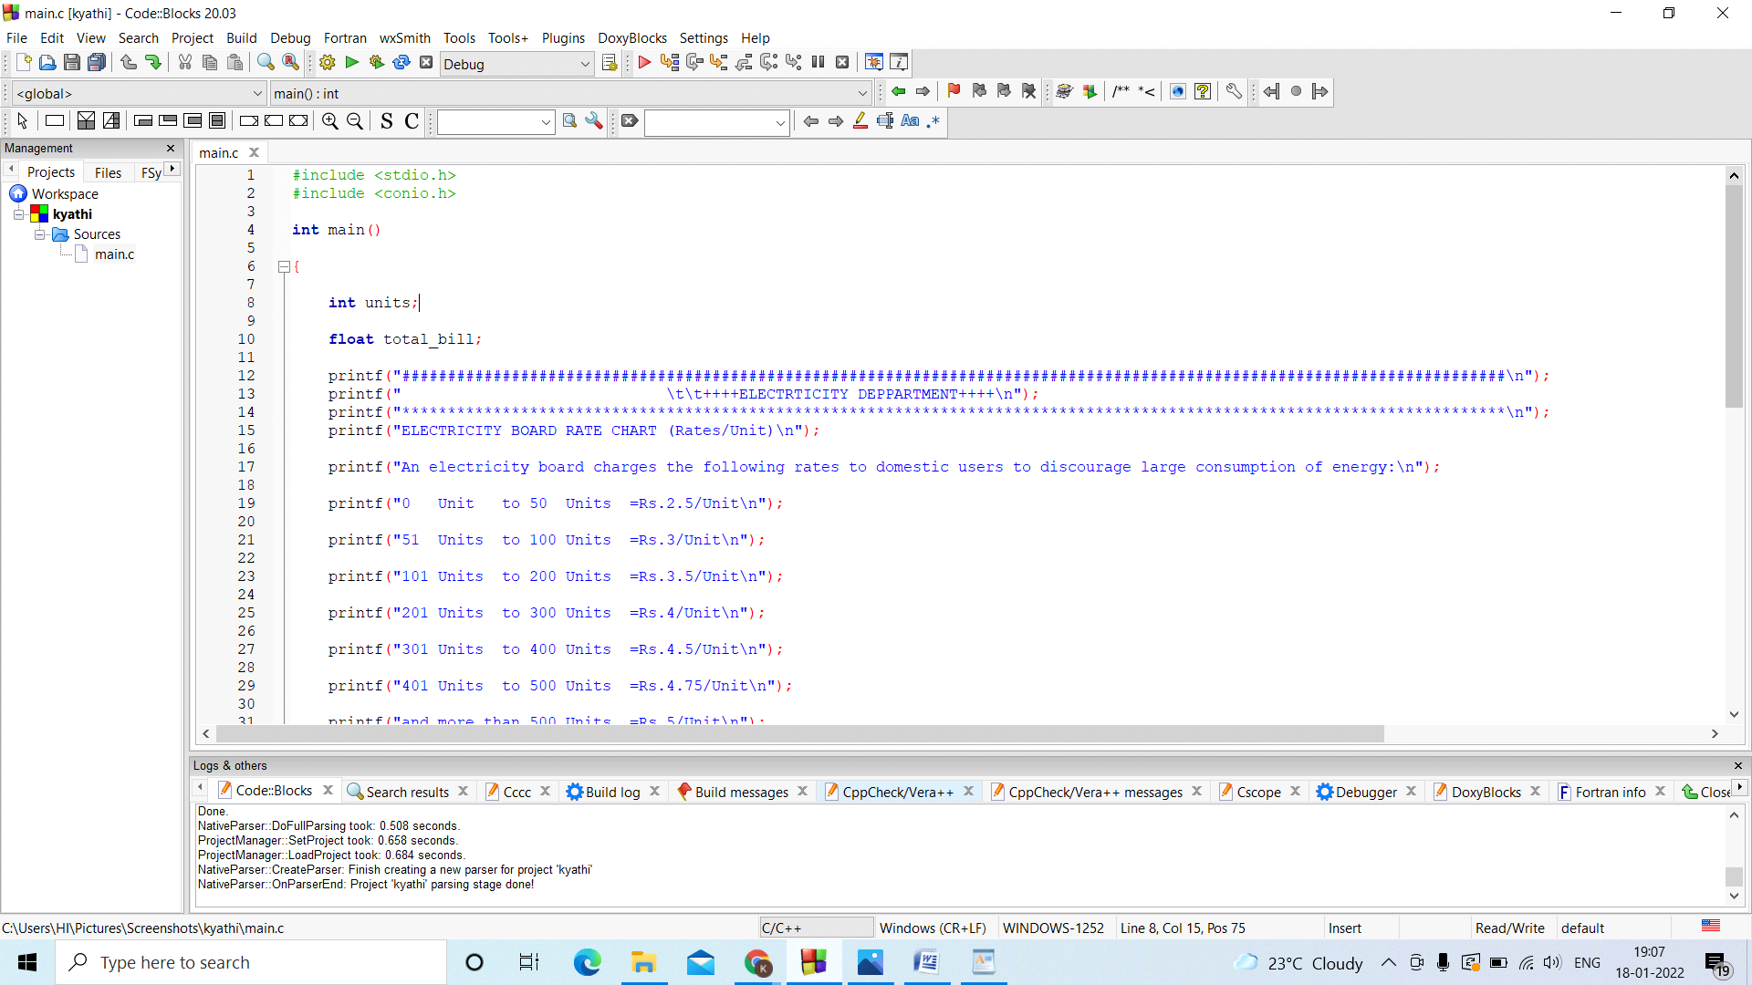

SCREENSHOT2:

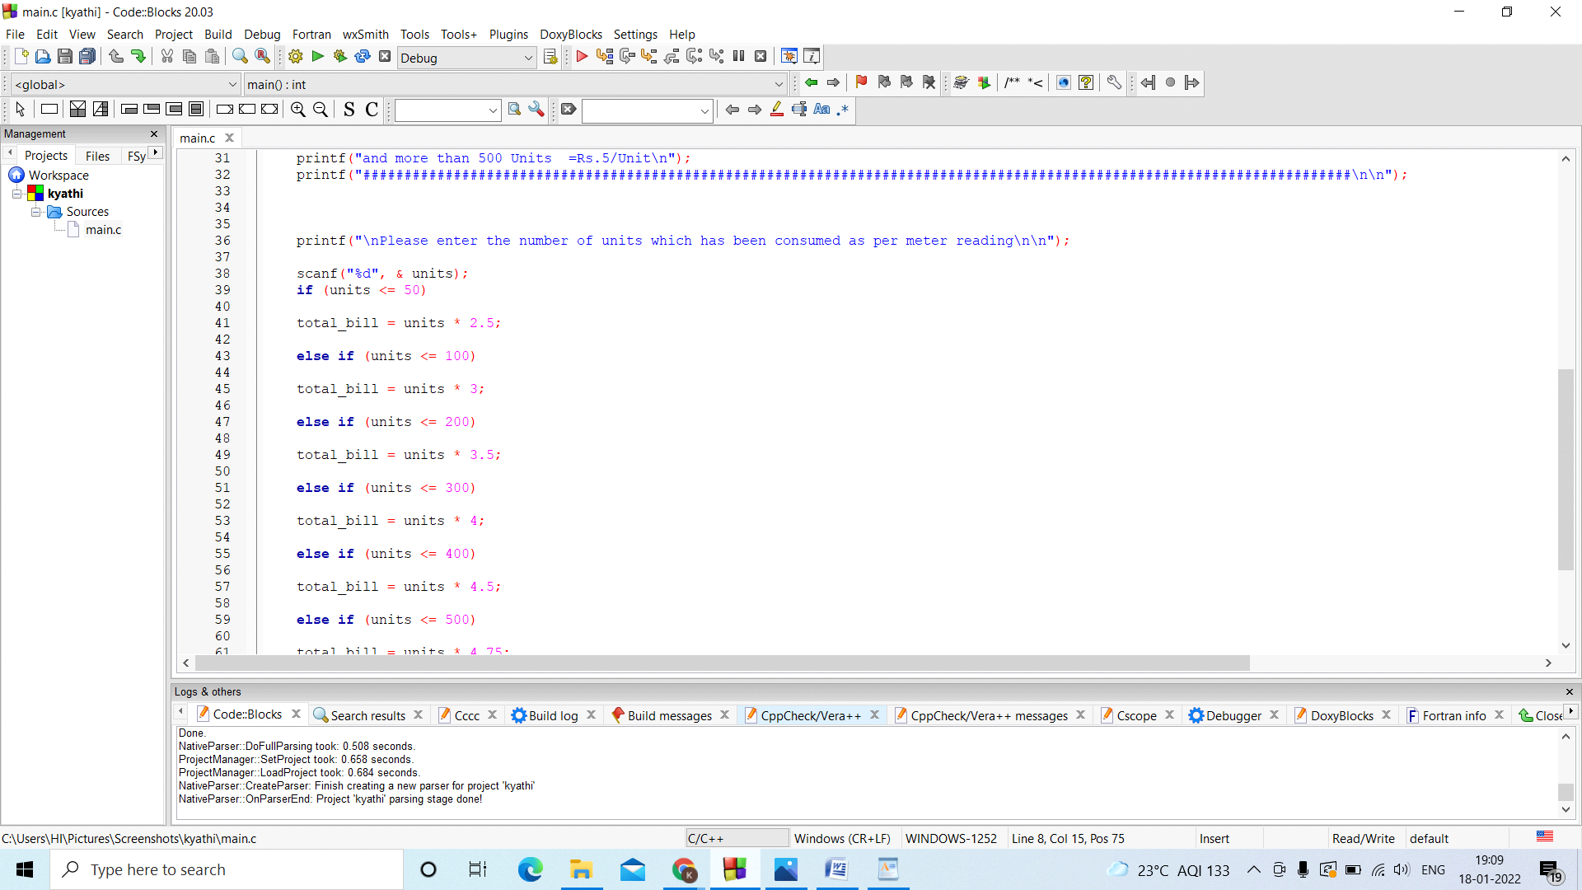

SCREENSHOT3:

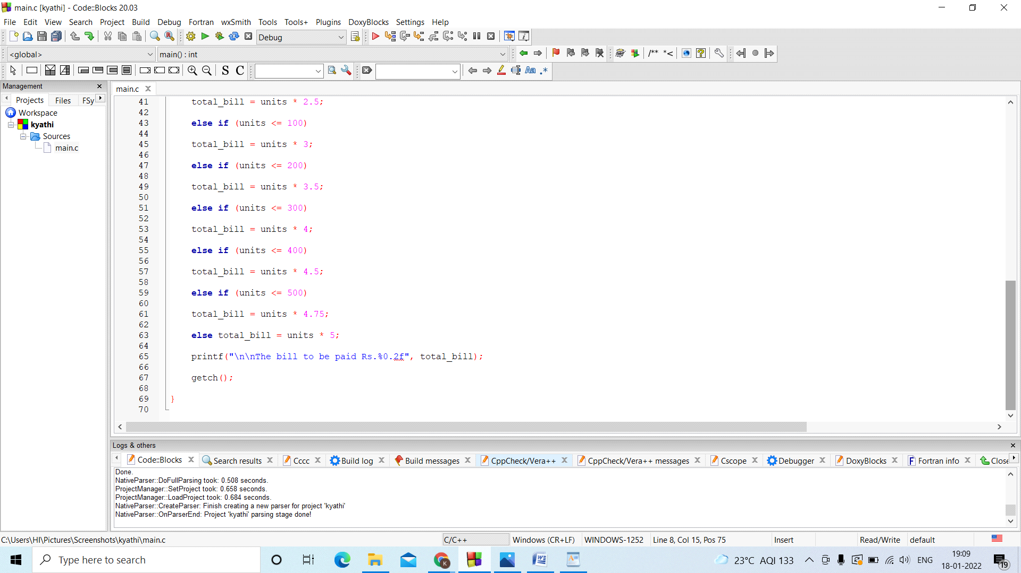

#algorithm for my code

Step 1:

start

Step 2:

Initialize variables

Step3:

Take the input from the user.

Step4:

Case1: Units are <50 it costs 5rupees per unit.

Case2: Units are <100it costs 5.5rupees per unit.

Case3: Units are <200it costs 6 rupees per unit.

Case4: Units are<300it costs 6.5 rupees per unit.

Case5: Units are<400it costs 7 rupees per unit.

Case6:Units are<500it costs 7.5rupees per unit.

Case5:Units are>500it costs 8 rupees per unit.

Step5:

Display output according to the case that choosed by the user.

Step6: Stop.

#Flowchart:

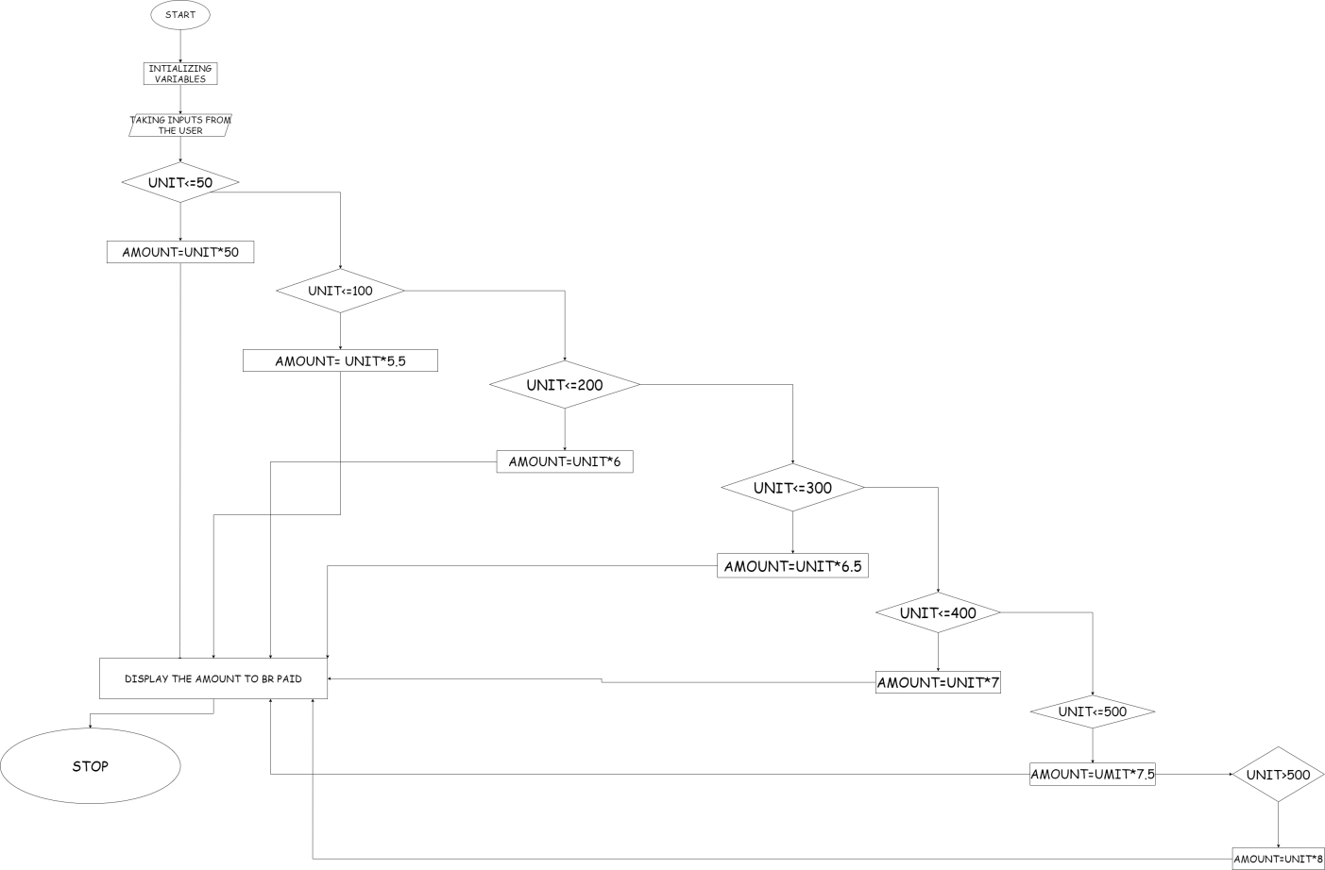

OUTPUT SCREENSHOTS:

